System modification

**Hi, first change.**

Go to the mlc folder in the server computer then open the file called ‘editUser.php’. You can open it with notepad (If notepad does not appear in the open with list you can open notepad separately the drag the file to it). Then locate the word ‘$cart;’ and change it to ‘$row["category"];’ as shown below. You can copy them from here, excluding the quotes ‘’.

**Before**

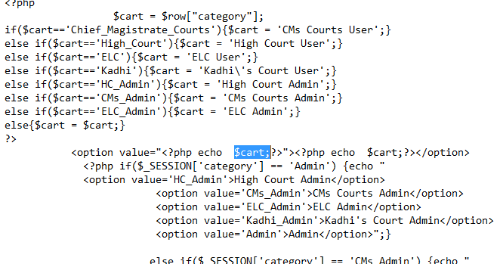

**After**

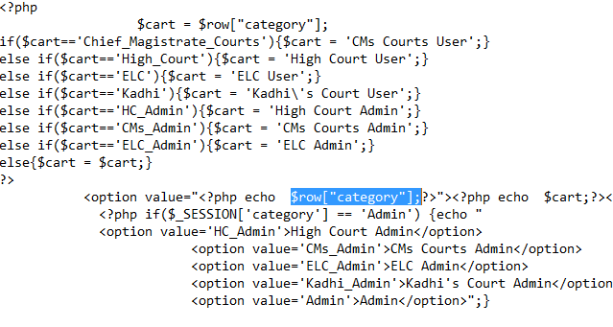

**Try to do exactly that, ensuring that ; are in place. Thank you**

**Second Change**

Go to mlc and open the includes folder then open a file named ‘login_form_admin’ and make the change illustrated below

**Before**

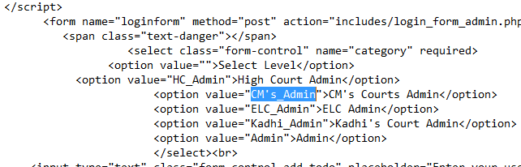

**After**

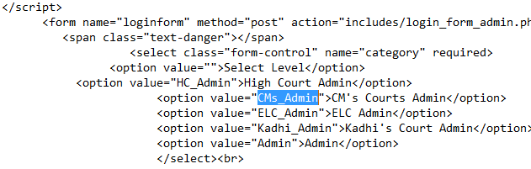

**Remove the apostrophe ‘**

**Third Change**

Go to mlc then open the file named ‘admin.php’ and make the following modification

**Before**

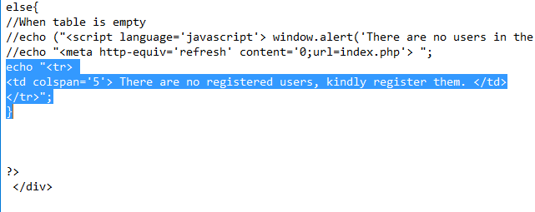

**After**

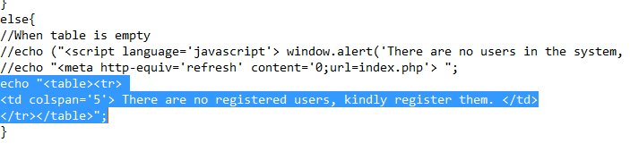

Add the tags <table> and </table>